This is the Updated Version of Paper Template of Irish Interdisciplinary Journal of Science & Research

Fist Author¹, Second Author² & Third Author³

¹First Author’s Department, Institution with Address, Country & Email.
²Second Author’s Department, Institution with Address, Country & Email.
³ThirdAuthor’s Department, Institution with Address, Country & Email.

Article Received: XX May 2020 Article Accepted: XX July 2020 Article Published: XX August 2020
ABSTRACT
Osteoarthritis is a degenerative joint disease that is the most common type of arthritis. Causes OA is caused by joint damage. This damage can accumulate over time, which is why age is one of the main causes of the joint damage leading to osteoarthritis. Osteoarthritis occurs when the cartilage that cushions the ends of bones in your joints gradually deteriorates. Cartilage is a firm, slippery tissue that enables nearly frictionless joint motion. It causes changes in the bone and deterioration of the connective tissues that hold the joint together and attach muscle to bone. The aim of the study was to determine efficacy and safety of the efficacy and safety of curcumin with those of diclofenac in the treatment of knee osteoarthritis (OA), who is intolerant to the side effects of non-steroidal anti-inflammatory drugs. A total of 80 patients were enrolled as per inclusion and exclusion criteria, patients were participated in this study, and the response was 100%. The diagnosis of Osteoarthritis in the study subjects was based on the following clinical symptoms history of Nausea, vomiting, Diarrhea, Abdominal pain, Constipation, Dyspepsia, Weakness at the first day of pharmacokinetic assessment. Curcumin has similar efficacy to diclofenac but demonstrated better tolerance among patients with knee OA. In Ortholord™ Curcumin can be an alternative treatment option in the patients with knee OA who are intolerant to the side effects of non-steroidal anti-inflammatory drugs.
Keywords: Curcumin, Osteoarthritis, Diclofenac.
1. Introduction (Every content from Introduction to References – Times New Roman 11 Size, 1.5 Line Spacing & 6 Points after Text)
Osteoarthritis is the most common form of arthritis, affecting millions of people worldwide. It occurs when the protective cartilage that cushions the ends of your bones wears down over time. Although osteoarthritis can damage any joint, the disorder most commonly affects joints in your hands, knees, hips and spine.
Causes (Subheadings should be Italic)
Causes OA is caused by joint damage. This damage can accumulate over time, which is why age is one of the main causes of the joint damage leading to osteoarthritis. Osteoarthritis occurs when the cartilage that cushions the ends of bones in your joints gradually deteriorates. Cartilage is a firm, slippery tissue that enables nearly frictionless joint motion. It causes changes in the bone and deterioration of the connective tissues that hold the joint together and attach muscle to bone. It also causes inflammation of the joint lining.
The older you are, the more wear and tear you’ve had on your joints. Other causes of joint damage include past injury, such as:
(1) Torn Cartilage, (2) Dislocated Joints, (3) Ligament Injuries
Symptoms
- Stiffness
- Inflammation
- Tenderness (discomfort when pressing on the area with your fingers)
Osteoarthritis symptoms develop slowly and worsen over time. Signs and symptoms of osteoarthritis include: Pain, Stiffness, Tenderness, Loss of flexibility, range of motion, Grating sensation, Bone spurs, swelling.
2. Aim and Objectives
Aim
The aim of the study was to evaluate the Safety and efficacy of curcumin versus diclofenac in knee osteoarthritis.
Objective
The purpose of this study was to compare the efficacy and safety of curcumin with those of diclofenac in the treatment of knee osteoarthritis (OA).
3. Materials and Methods
Shep et al. Trials (2019): This study compared the efficacy and safety of curcumin with those of diclofenac in the treatment of knee osteoarthritis (OA). In this randomized, open-label, parallel, active controlled clinical study, 139 patients with knee OA were randomly assigned to receive either a curcumin 500-mg capsule three times daily or a diclofenac 50-mg tablet two times daily for 28 days. Patients underwent assessment at baseline and days 7, 14 and 28.
The main outcome measure was severity of pain using visual analogue scale score at days 14 and 28. Knee Injury and Osteoarthritis Outcome Score (KOOS) (At days 14 and 28), anti-flatulent effect (at day 7), anti-ulcer effect, weight-lowering effect, and patient’s and physician’s global assessment of therapy at day 28were included as secondary outcome measures. Safety after treatment was evaluated by recording adverse events and laboratory investigation. At days 14 and 28, patients receiving curcumin showed similar improvement in severity of pain and KOOS scale when with compared with diclofenac, and the difference was not statistically significant.
At day 7, the patients who received curcumin experienced as significantly greater reduction in the number of episodes of flatulence compared with diclofenac (p<0.01). At day 28, a weight-lowering effect (P<0.01) and anti-ulcer effect ( P<0.01) of curcumin were None of the patients required H2 blockers in the curcumin group, and 19 patients required H2 blockers in the diclofenac group ( 0% versus 28%, respectively, P<0.01). Adverse effects were significantly less in the curcumin group (13% versus, 28% respectively, P<0.01. Patients and physician’s global assessment of therapy was similar in the two treatment groups.
Curcumin has similar efficacy to diclofenac but demonstrated better tolerance among patients with knee OA. Curcumin can be an alternative treatment option in the patients with knee OA who are intolerant to the side effects of non-steroidal anti-inflammatory drugs
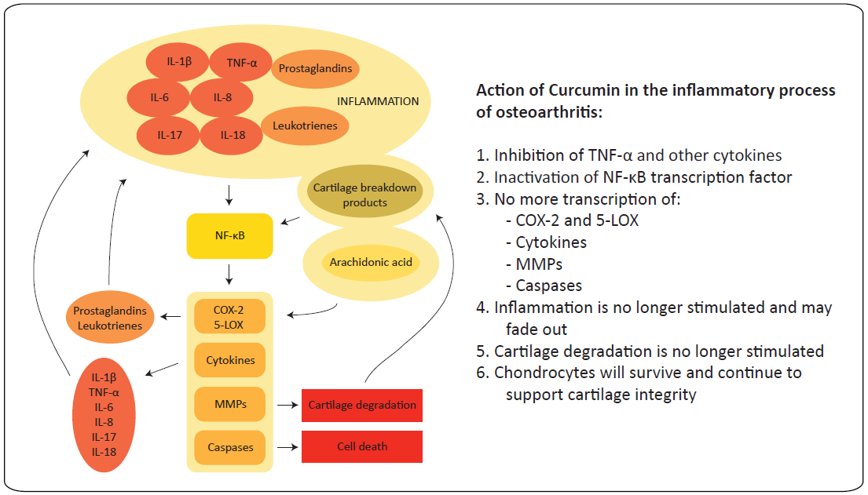
Fig.1: Schematic image of the processes in osteoarthritis, in which Curcumin could play a role to restore the healthy processes (Figures should be numbered as Fig.1)
4. Result
A total of 80 patients were enrolled as per inclusion and exclusion criteria, patients were participated in this study, and the response was 100%. Demographic and baseline characteristics in patients with knee osteoarthritis Safety and efficacy of curcumin versus diclofenac in knee osteoarthritis: a randomized open-label parallel-arm study.
The diagnosis of Osteoarthritis in the study subjects was based on the following clinical symptoms history of Nausea, vomiting, Diarrhea, Abdominal pain, Constipation, Dyspepsia, Weakness at the first day of pharmacokinetic assessment. In Ortholord ™ Curcumin can be an alternative treatment option in the patients with knee OA who are intolerant to the side effects of non-steroidal anti-inflammatory drugs.
Table 1: Summary of adverse reactions in each treatment group
Adverse reactions | Curcumin  (N=70)  n% | Diclofenac  (N=69)  N% | RR | RRLB | RRUB | NNT
Total number of Patients experiencing AE’s | 9 (13%) | 26 (38%)
Dyspepsia | 0 | 6 (8.7%) | 0.08** | 0 | 1.3 | 12
Nausea | 6 (9%) | 7 (10.14%) | 0.8 | 0.3 | 2.4 | 64
Vomiting | 0 | 7 (10.14%) | 0.07** | 0 | 1.1 | 10
Diarrhea | 5 (7%) | 8 (11.6%) | 0.6 | 0.2 | 1.8 | 23
Constipation | 0 | 6 (8.7%) | 0.08** | 0 | 1.3 | 12
Abdominal pain/acidity | 0 | 19 (27.53%) | 0.03** | 0 | 0.4*** | 4
Flatulence | 0 | 9 (13.04%) | 0.05** | 0 | 0.9*** | 8
Upper respiratory tract infection | 0 | 5 (7.25%) | 0.09** | 0 | 1.6 | 14
Abbreviations: a treatment group, b control group, n number of patients in each category, N total number of patients in each treatment group, NNT number needed to treat, RR relative risk, RRLB relative risk lower boundary, RRUB relative risk upper boundary
*P <0.01 for curcumin versus diclofenac
**Clinically significant adverse event (AE) (RR <0.5)
***Statistically significant AE (95% confidence interval does not include 1)
Table 2: Comparison of pain as determined by visual analogue scale in patients with knee Osteoarthritis
Visit | Curcumin  (N=70) | Diclofenac  (N=69) | p value
Baseline | 7.8±0.63 | 7.81±0.73 | 0.79t
Day 14 | 4.69±0.79 | 4.58±0.60 | 0.38†
Day 28 | 2.20±0.81 | 2.20±0.61 | 0.98t
Change at Day 14 | -3.16±0.79 | -3.23±0.91 | 0.61t
Change at Day 28 | -5.93±0.99 | -5.61±0.88 | 0.82t
p value | P<0.01 | P<0.01
VAS reduction % ≤ 50 | N=4 | N=2 | P=0.68f
VAS reduction % > 50 | N=66 | N=67

5. Discussion
Curcumin lowers the production of prostaglandins and COX-2 in the cells of inflamed joint mucous membranes, and it lowers the number of mucous-membrane cells in a controlled manner. As such, Curcumin has a positive effect on the degenerative inflammation process in joint diseases, including rheumatoid arthritis and osteoarthritis. . Curcumin can be an alternative treatment option in the patients with knee OA who are intolerant to the side effects of non-steroidal anti-inflammatory drugs. Osteoarthritis is a degenerative joint disease that is the most common type of arthritis. Causes OA is caused by joint damage. This damage can accumulate over time, which is why age is one of the main causes of the joint damage leading to osteoarthritis. Visual analogue scale is from 0 to 10, where 0 indicates “No pain” and 10 indicate “Worst possible pain”. Both treatment groups showed a significant reduction in VAS scores from their baselines. The numbers of patients having more than 50% improvement in VAS score in curcumin group and in the diclofenac group. Curcumin has similar efficacy to diclofenac but demonstrated better tolerance among patients with knee OA.
6. Safety variables
Overall patients receiving curcumin and diclofenac reported at least one AE and this difference was statistically significant (P <0.01). All reported AEs were mild and transient. The most common AEs were nausea, diarrhea, abdominal pain/acidity, and flatulence. The incidence of each AE was significantly less in the curcumin group compared with the diclofenac group. Curcumin has a positive effect on the degenerative inflammation process in joint diseases, including rheumatoid arthritis and osteoarthritis.
7. Conclusion
To conclude that Curcumin has similar efficacy to diclofenac but demonstrated better tolerance among patients with knee OA. Curcumin can be an alternative treatment option in the patients with knee OA who are intolerant to the side effects of non-steroidal anti-inflammatory drugs.
References (References are to be numbered & cited inside text)
1. Fransen M, Bridgett L, March L, Hoy D, Penserga E, Brooks P. The epidemiology of osteoarthritis in Asia, Int J Rheum Dis, 2011, Vol no: 14, Page no: 113–121.
2. Riyazi N, Rosendaal FR, Slagboom E, Kroon HM, Breedveld FC, Kloppenburg M. Risk factors in familial osteoarthritis: the GARP sibling study, Osteoarthr Cartil, 2008, Vol no:16, Page no: 654–659.
3. Gonzalez Sáenz de Tejada M, Escobar A, Herrera C, García L, Aizpuru F, Sarasqueta C. Patient expectations and health‐related quality of life outcomes following total joint replacement, Value Health, 2010, Vol no: 13, Page no: 447–454.
4. Focht BC, Move to improve: how knee osteoarthritis patients can use exercise to enhance quality of life, ACSMs Health Fit J, 2012, Vol no:16, Page no: 24–28.
5. Cook C, Pietrobon R, Hegedus E. Osteoarthritis and the impact on quality of life health indicators. Rheumatol Int. 2007, Vol no: 27, Page no: 315–321.
6. Dominick KL, Ahern FM, Gold CH, Heller DA, Health-related quality of life among elder adults with arthritis, Health Qual Life Outcomes, 2004, Vol no: 2, Page no: 5.]
7. Hadler NM. Knee pain is the malady-not osteoarthritis. Ann Intern Med, 1992, Vol no: 116, 598–599.
8. Ayis S, Dieppe P. The natural history of disability and its determinants in adults with lower limb musculoskeletal pain, J Rheumatol, 2009, Vol no: 36, Page no: 583–591.
9. Dominick KL, Ahern FM, Gold CH, Heller DA, Health-related quality of life and health service use among older adults with osteoarthritis, Arthritis Rheum, 2004, Vol no: 51, Page no: 326–331.
10. McAlindon TE, Cooper C, Kirwan JR, Dieppe PA.Determinants of disability in osteoarthritis of the knee. Ann Rheum Dis, 1993, Vol no: 52, Page no: 258–262.
11. Sangdee C, Teekachunhatean S, Sananpanich K, Sugandhavesa N, Chiewchantanakit S, Pojchamarnwiputh, Electroacupuncture versus Diclofenac in symptomatic treatment of osteoarthritis of the knee: a randomized controlled trial, BMC Complement Altern Med, 2002, Vol no: 2, Page no: 3.
12. Tannenbaum H, Berenbaum F, Reginster JY, Zacher J, Robinson J, Poor G, Lumiracoxib is effective in the treatment of osteoarthritis of the knee: a 13 week, randomised, double blind study versus placebo and celecoxib, Ann Rheum Dis. 2004, Vol no: 63, Page no: 1419–1426.
13. Yves Henrotin, Fabian Priem, and Ali Mobasheri, Curcumin: a new paradigm and therapeutic opportunity for the treatment of osteoarthritis: curcumin for osteoarthritis management, Springerplus. 2013; 2: 56.
14.Y.Henrotina,A.L.Clutterbuck,D.Allaway,E.M.Lodwig,P.Harris§M.Mathy-Hartert,M.Shakibaei∥A.Mobasheri, Biological actions of curcumin on articular chondrocytes, Volume 18, Issue 2, February 2010, Pages 141-149.
15. Janet L. Funk Jennifer B. Frye Janice N. Oyarzo Nesrin Kuscuoglu Jonathan Wilson Gwen McCaffrey Gregory Stafford Guanjie Chen R. Clark Lantz Shivanand D. Jolad Aniko M. Sólyom Pawel R. Kiela Barbara N. Timmermann, Efficacy and mechanism of action of turmeric supplements in the treatment of experimental arthritis, Volume 54, Issue 11, November 2006, Pages 3452-3464.

